**Power BI in one line:**Power BI is Microsoft’s business analytics tool that helps visualize, share, and interact with data through dashboards and reports.

**Features of Power BI (3 lines with examples):**

1. Data Connectivity & Integration – Connects to 100+ data sources (e.g., Excel, SQL Server, Azure, Salesforce).
2. Interactive Visualizations & Dashboards – Drag-and-drop charts, maps, KPIs (e.g., sales dashboard showing revenue by region).
3. AI & Natural Language Queries – Users can type questions like *“Show sales growth by month”* and get instant visuals.

**Feature Tableau has that Power BI doesn’t:**👉 Tableau has better advanced data visualization customization (e.g., more granular control over design, formatting, and storytelling dashboards).

**Feature Power BI has that Tableau doesn’t:  
👉** Power BI offers seamless integration with Microsoft ecosystem (Excel, Teams, Azure, Power Apps) and AI-powered insights directly inside the tool.

**WAYS TO IMPORT DATA IN POWER BI**

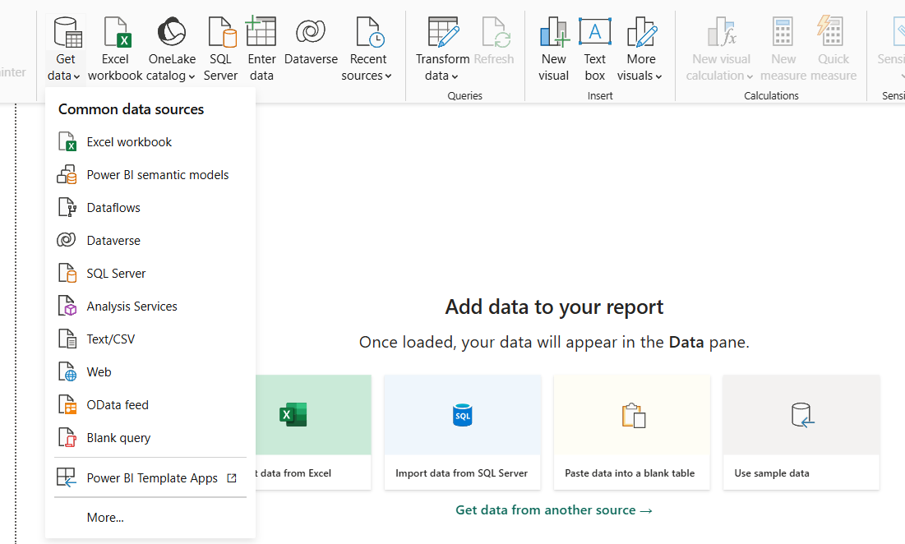

**IMPORTING EXCEL SHEET**

When we import the excel sheet data it will shows the list of sheets available in that file like below.

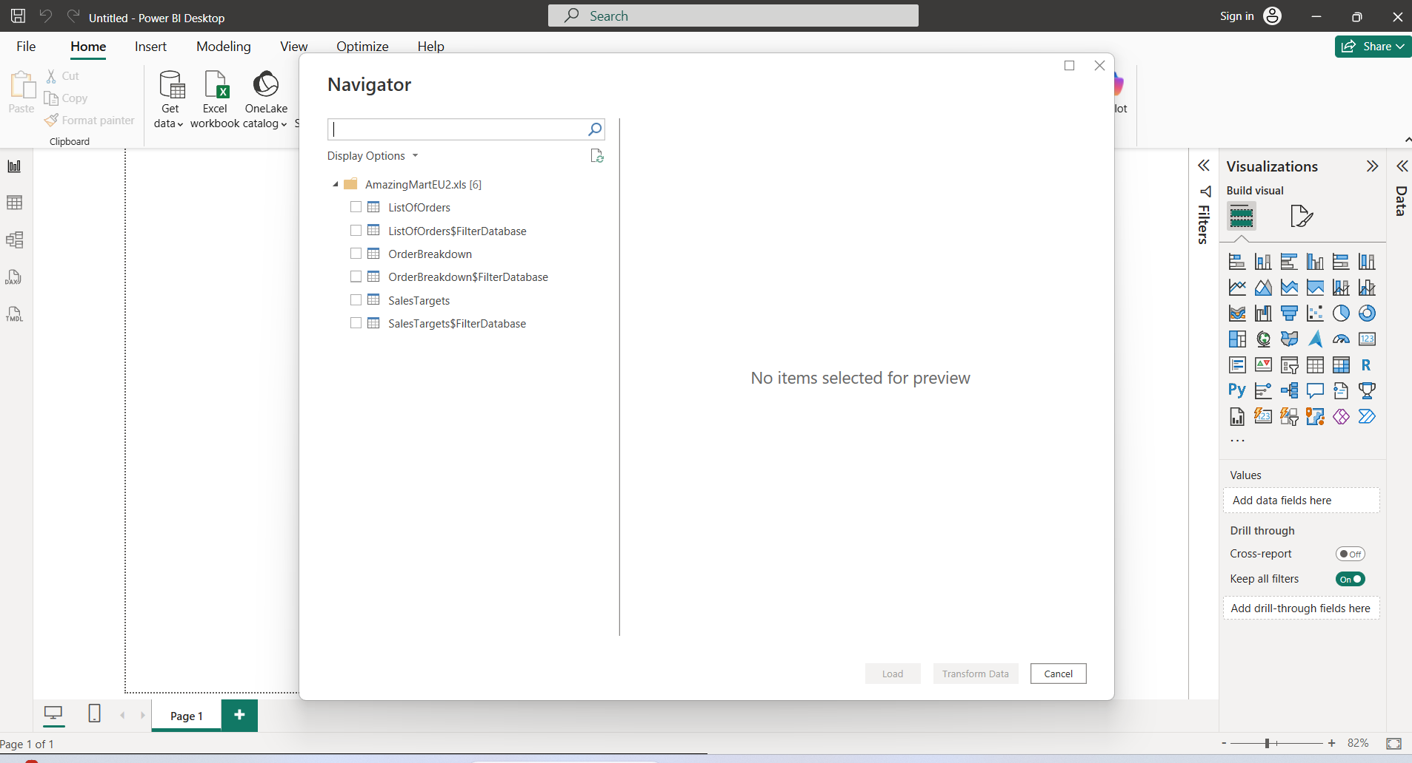

Below is the way we can select the needed sheet to work with power bi,

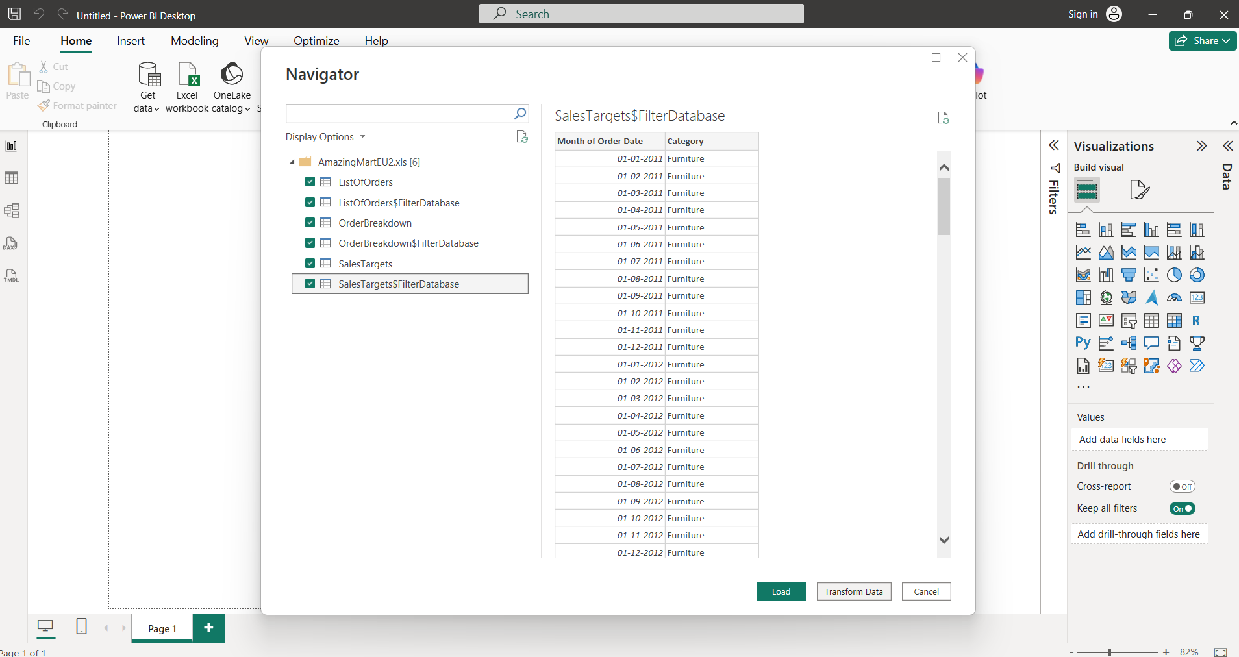

Transform Data = clean/shape data before use, Load Data = bring prepared data into Power BI for reporting. ✅

Below is the initial page when data gets load into the power BI, in left corner it has list of view the highlighted view is table, first view is visualization, third view are helps to see the relationship among different sheet.

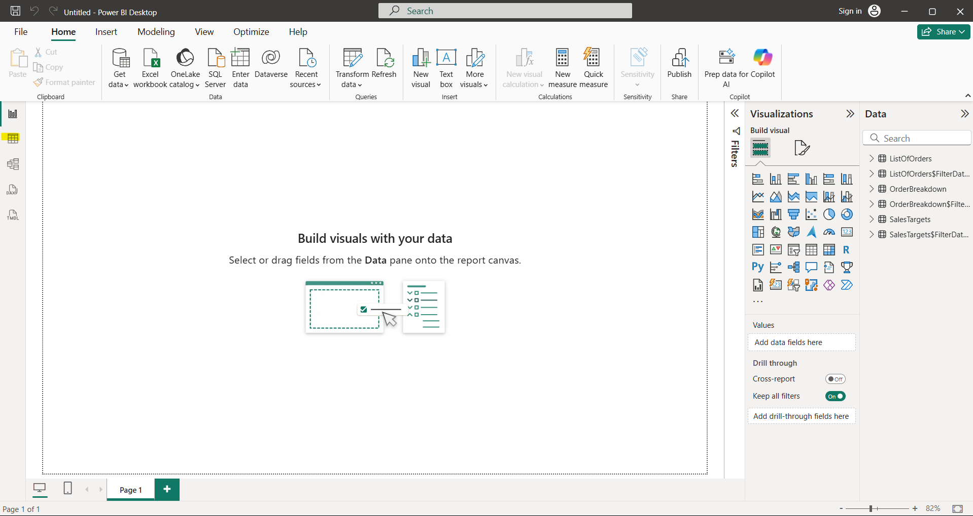

**TRANSFORM DATA IN POWER BI**

With this we an remove add columns

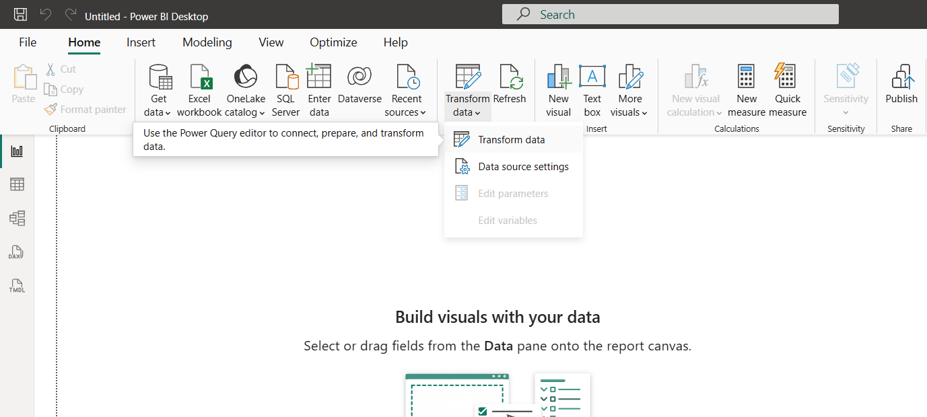

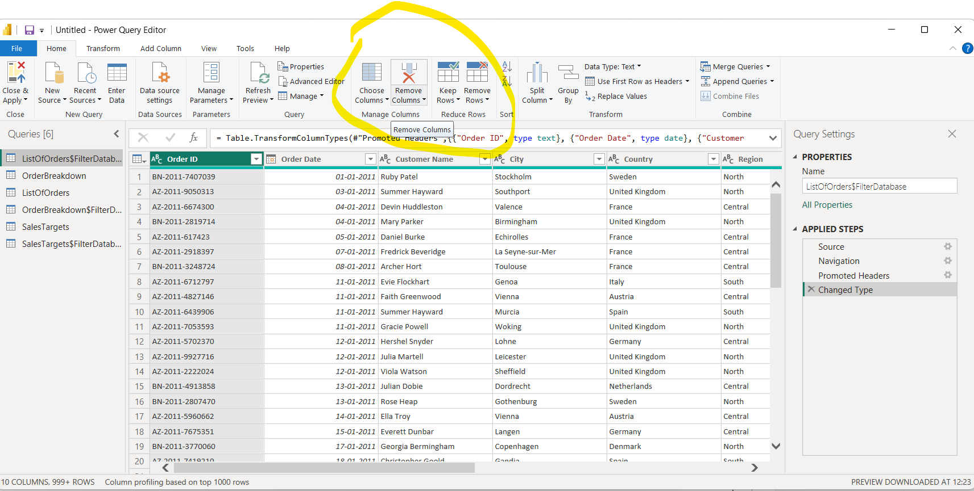

**FILTERING DATA**

All the values will be shown on filter type drop down when we drag and drop the fields into the filter on this page container, by clicking those values we can filter out the data.

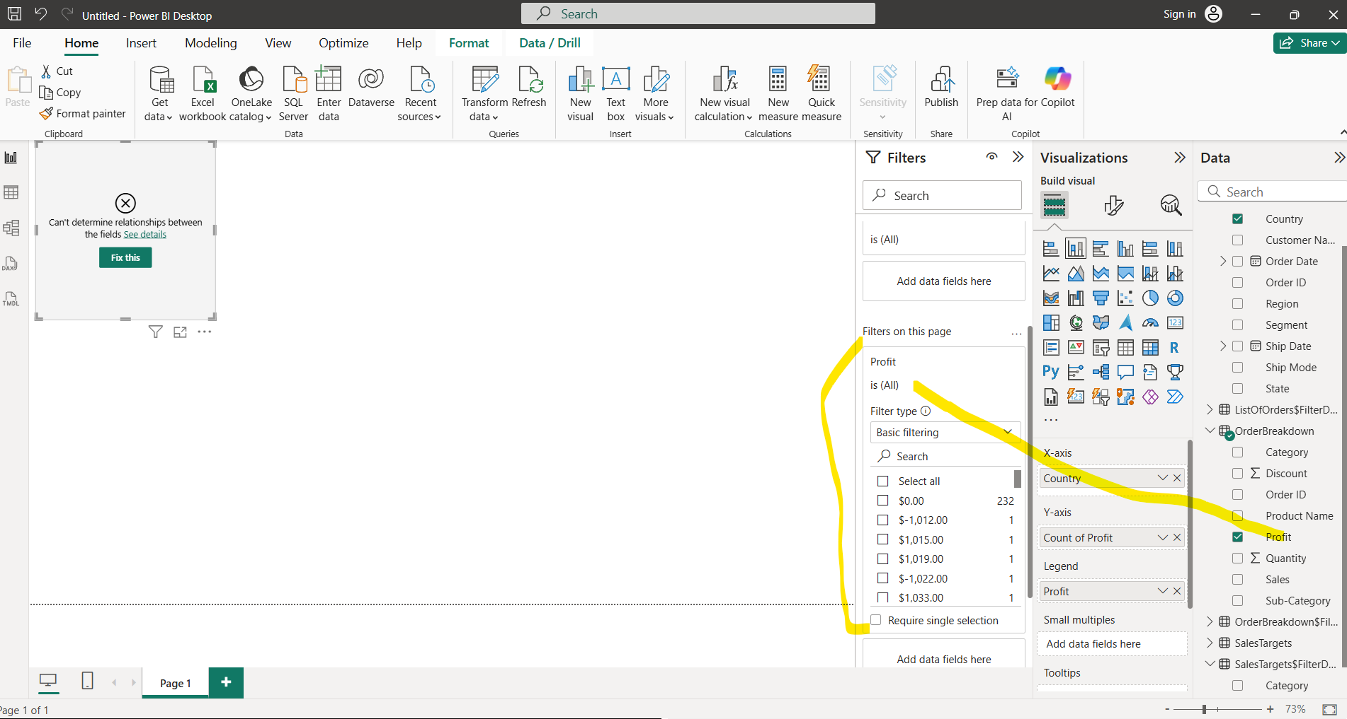

**FOCUS MODE**

Helps to see the full chart in the current page.

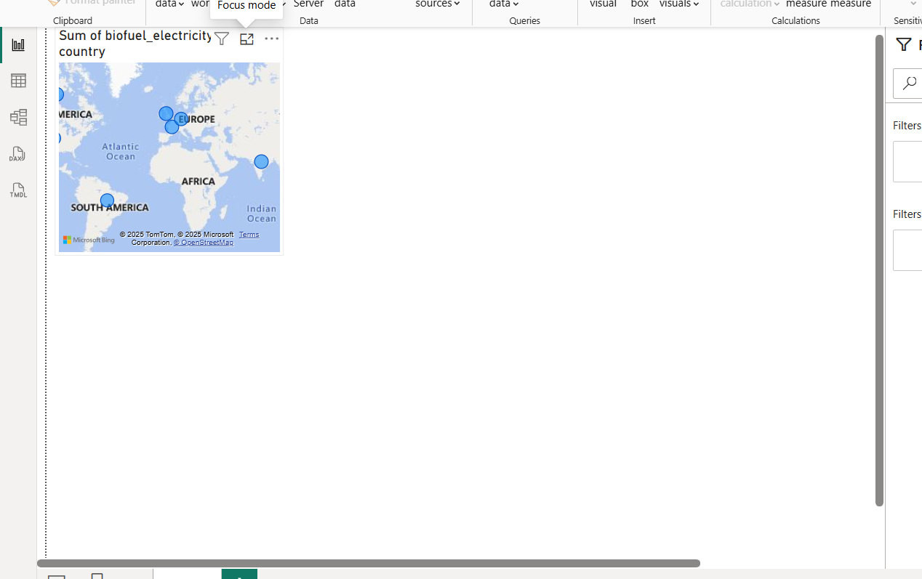

After clicking the focus mode

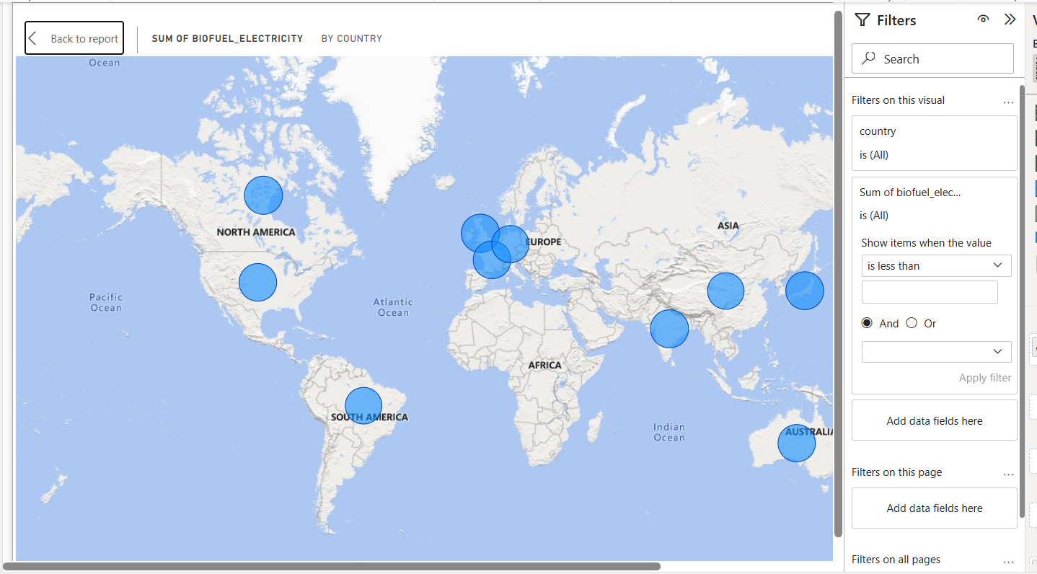

**Note:**

In Power BI, the **Map visual** (or Filled Map) requires some kind of **geographic data** such as:

* Country / State / City
* Latitude & Longitude
* Postal Code / Region

If your dataset (like the one we generated) has **no location-type columns**, then:

* When you try to drag a field into the **Location** well of a Map visual, Power BI won’t know how to plot it.
* It may show an empty map or an error message like *“More location data is needed to create a map.”*
* Power BI might try to guess (for example, treat a column like “token” or “obyte” as location text), but it won’t map correctly unless those values match real geographic names.

✅ To make it work, you’d need to add a **location field** (like "Country" or "City") to the dataset.

**FORMAT CHART LABELS, LEGENDS**

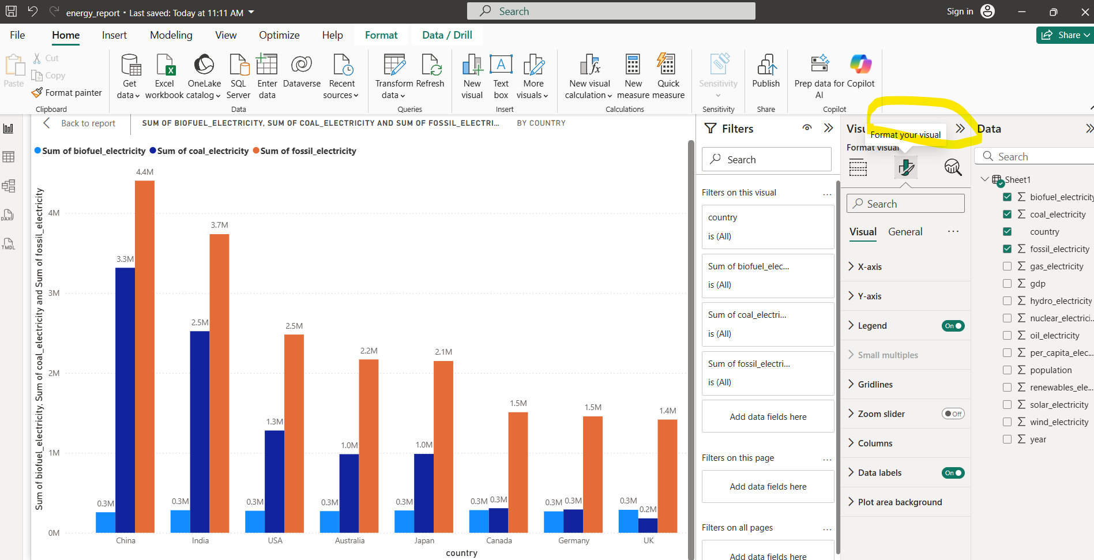

**FILE EXTENSIONS IN POWER BI**

**PBIX** stands for **Power BI eXecutable** (commonly interpreted this way by the community, though Microsoft doesn’t officially expand it).

Other related Power BI file extensions are:

* **.pbit** → **Power BI Template**
* **.pbix** → **Power BI report file (main working file)**

**TOP N FOR BAR CHART**

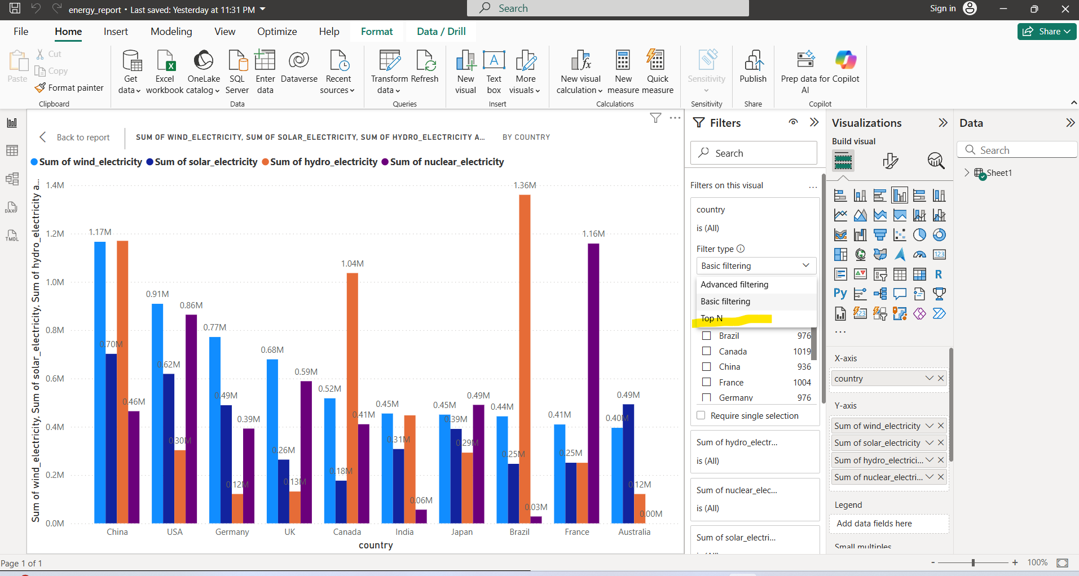

The below chart will displays the Top 5 records which as high hydro energy

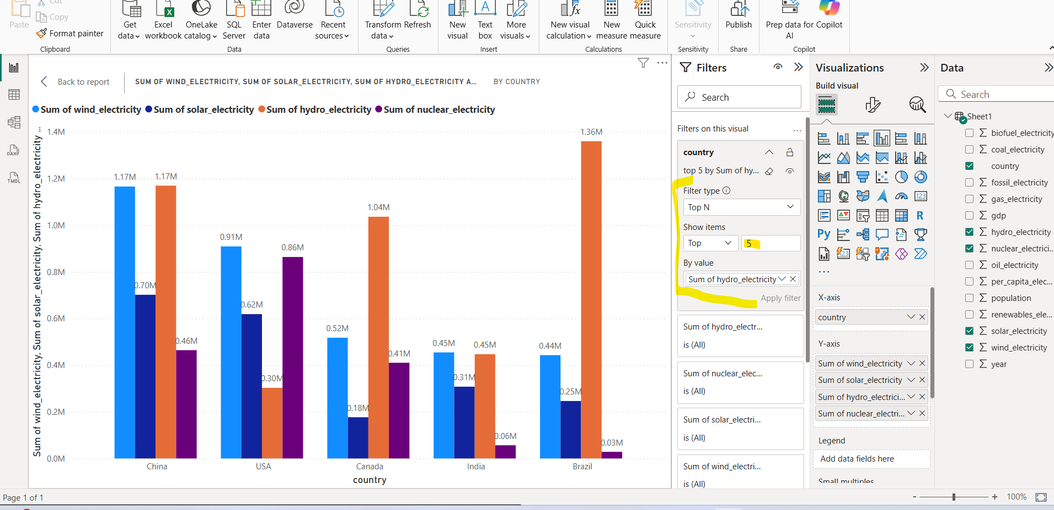

**EXPORTING DATA FROM CHART**

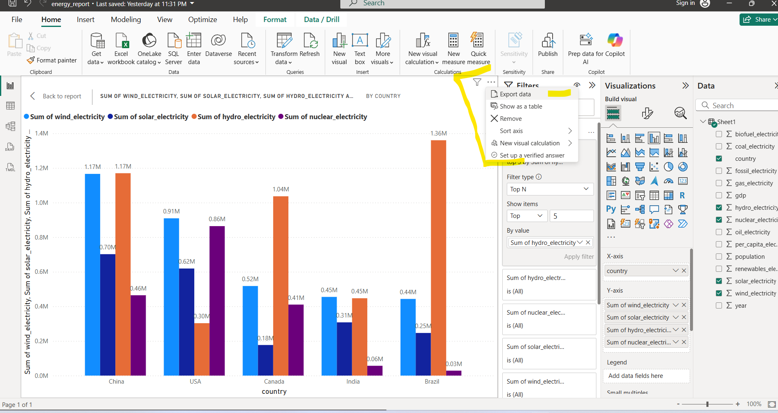

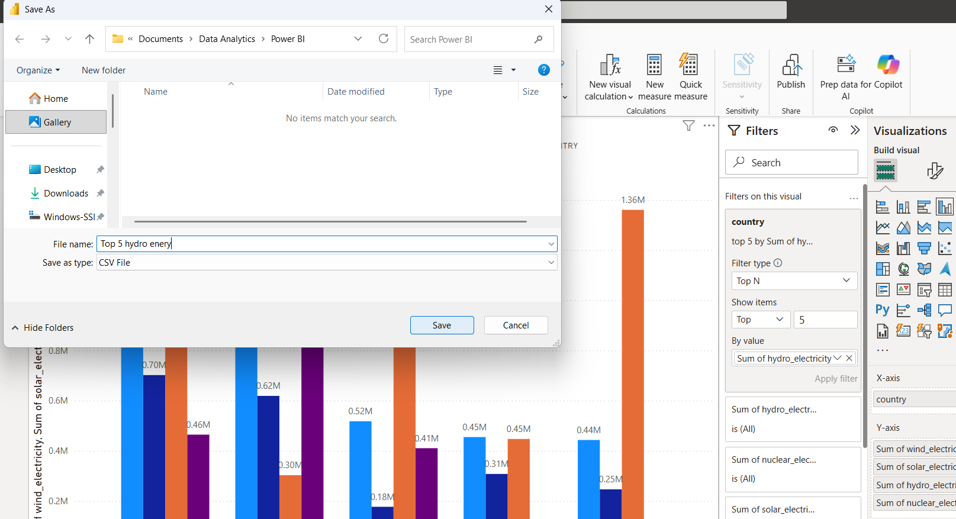

**CHANGING DATA TYPE OF THE COLUMN**

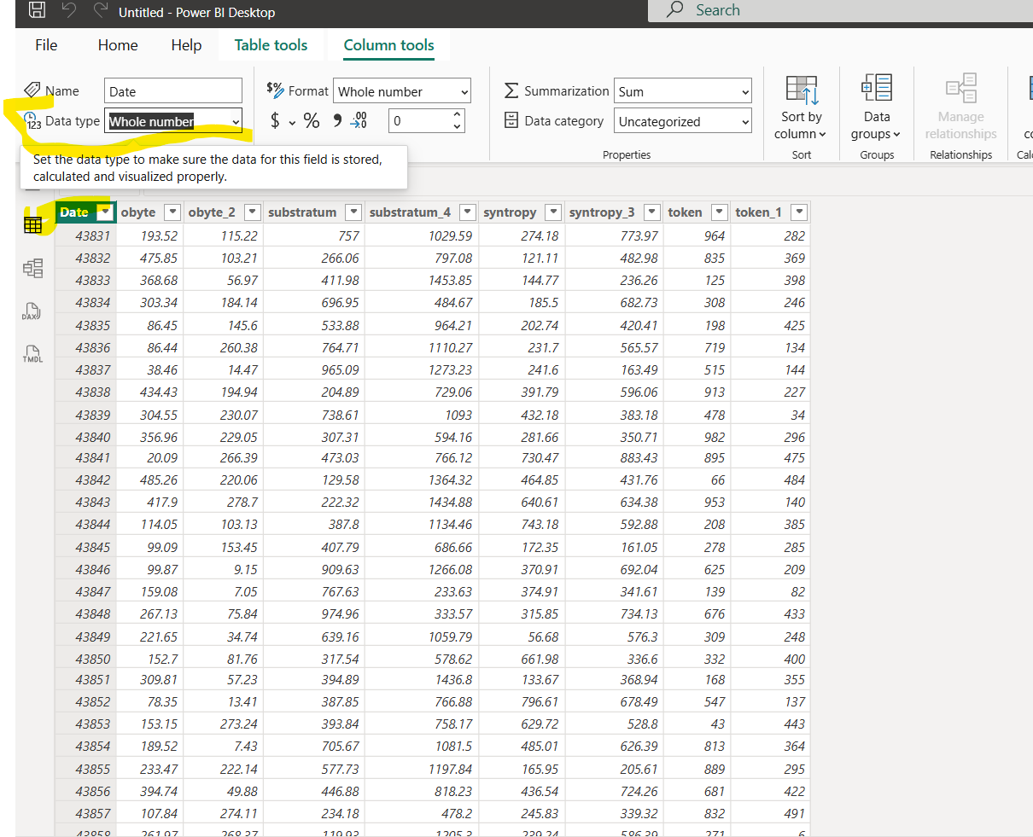

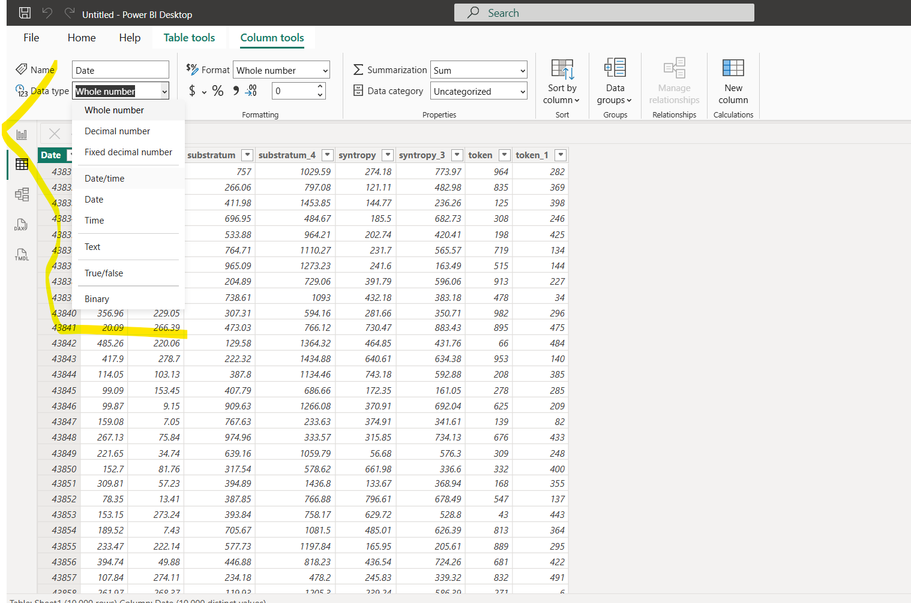

After changing the column to Date/Time the column will look like below

